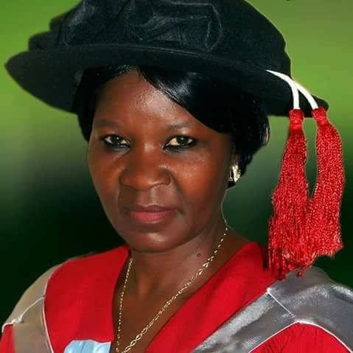

HYACINTH OKORO
08066879006
hymanndavid@gmail.com

Professor Naomi Nari James-Rugu

LILIUM INTER-SPINAS.
The seeker of knowledge she is, and knowledge defines civilization, the enforcer of academic well-whether as an astute academia.
Professor Naomi Nari James-Rugu is a true Josite and a great team leader, a member of various professional bodies, an academia, a philanthropist, a woman of unparallel versatility.
Her working experiences permeates all works of human endavours; prominent among them are; Deputy Dean Faculty of Natural Sciences, University of Jos where she distinguished herself by her wonderful performance, Director Students Industrial Work Experience Scheme (SIWES). Professor N.N. James-Rugu is a dynamic leader.
She is full of competence and courage. She exercises a high spirit of team work. She is a gentle Orator, who is audible, clear, precise and attention catching. She is a teacher par excellence. Because of her hard work, Prof. James-Rugu has won the admiration of Past Vice Chancellors of University of Jos and has represented the Institution at different niche in the Country.
Professor N.N. James-Rugu’s extraordinary versatility made her a notable figure in the Faculty of Natural Sciences and University of Jos.

Today, Professor N.N. James-Rugu has become an encyclopedia of Natural Sciences where many had drawn zeal and morals. She authored many books and journals that had solved many problems in our society. She was a student of the Great late Professor Jerry Ajayi of the blessed memory; but I can say the greater than Ajayi has emerged!. Professor N.N.J.R is a leader with exemplary qualities, a mother to many, a teacher of morals, a lecturer with a difference and an ambassador of peace.
Professor James-Rugu as she is fondly called is an instructor and a mentor. She is a model of detachment and simplicity, a cheerful counselor and a paradigm of humility as well as an advocate for the weak. She is an academic luminary, a ready listener and a genuine giver.
She is also an apostle of positive change, a driver of devotions and commitment, a great visionary standing despite all the challenges in this parts of the world. I believed with the proverb that said “you cannot keep a good man down”. Professor N.N.J.R is a woman whose life and fruits had helped many lives to fulfill their destinies. Indeed she is a destiny helper. Her life justifies the biblical postulation which states that “the wise inherit honour, but fools get only shame” (Proverbs 3vs35).
In a close, I am not surprised on the promotions and honours she had achieved but; I should have been bastardized if she was not recognized and honour to justify the above scripture and encourage the students of her school of thought.

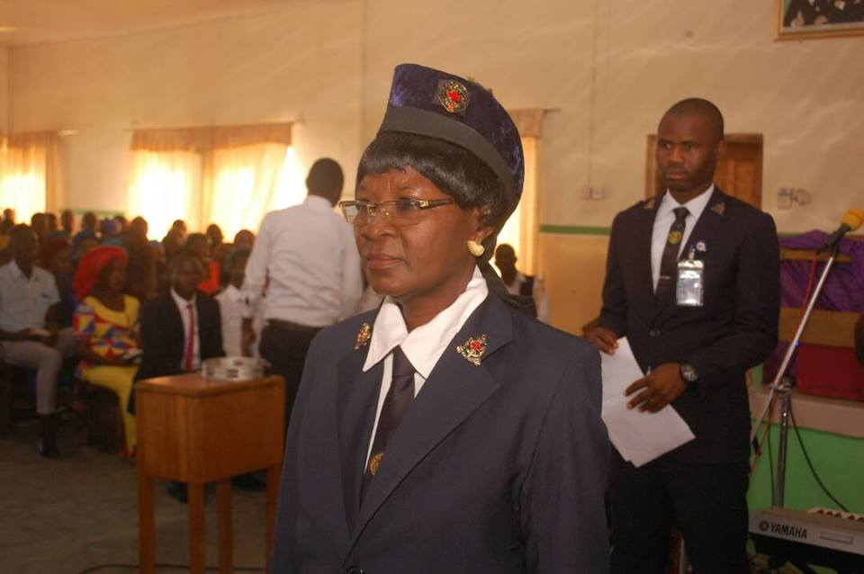
HYACINTH OKORO
08066879006
hymanndavid@gmail.com

Professor N.N.J.R
INVESTITURE.
Another feather on the head of a Great Philanthropist, an encyclopedia of peace, a woman of unparalleled versatility. She is Professor Naomi Nari James-Rugu .
On 21st October, 2018 Professor N.N.J.R, a mother to many was given an insignia as an inaugural mark as Patroness to Boys Brigade Nigeria at Jos North Battalion Company.
Professor N.N.J.R is a lecturer in University of Jos, Plateau State Nigeria. She is a lecturer with a difference, a tutor of morals. A model of detachment and simplicity, a counselor and paradigm of humility as well as an advocate for the weak.
Professor James-Rugu as she is called by many is a renowned apostle of positive change, a driver of devotions and commitment, a great visionary. A woman whose life and good works had helped many people to fulfill their destinies.

Professor N.N. James-Rugu's extraordinary versatility and good works had made her a notable figure in the university community and in areas where merit is given its prime place.
I believed in the saying that you cannot keep a good man down.
I am not surprised on the height you have attained, but it should have been a divestiture and discouraging to the apostles of your testament if you were not recognized.
Congratulations Ma.
HYACINTH OKORO
08066879006
hymanndavid@gmail.com


Professor Naomi Nari James-Rugu

Hurray Our Mummy is 58
She was born on 25th April 1961. She is Professor Naomi Nari James-Rugu. An academic luminary. A teacher of morals, an ambassador of peace, a genuine giver and an advocate for the weak.
Her life had proved the saying that; you cannot keep a good person down.
I wish your Divine Health, Long Life and Prosperity.
CONGRATULATIONS.
HAPPY BIRTHDAY.
HYACINTH OKORO
08066879006
hymanndavid@gmail.com

AN ACHIEVER, OUR HERO.
PROFESSOR NAOMI NARI JAMES-RUGU, is a graduate of Zoology from University of Jos. She holds a Master degree in Applied Entomology and Parasitology and PhD in Entomology from the University of Jos; this is why she is known as a true-bred Josite and many Josites and many Nigerians have been looking forward to see Professor N.N.J.R at a higher position in University of Jos.
Professor N.N.J.R had headed many offices in University of Jos, Deputy Dean, School of Post graduate Studies, Deputy Dean, Faculty of Natural Sciences, and Director of SIWES. During her regime as SIWES Director IT students received their entitlement from ITF immediately they completed their SIWES programme .
In her Faculty Prof. N.N.J.R is popularly known as "mother of Zoology" because of her amiable relationship with her students. As an external examiner to several Nigerian Universities; she ensured that her students excel through hard work.
On 21st October, 2018 Prof. N.N.J.R was given an insignia as Patroness to Boys Brigade Nigeria at Jos North Battalion Company for her unblinking effort in voluntary promotion of human welfare (VPHW).
I am proud of you Ma; and all the Josites are of the same voice; saying you are a distinguished leader and a mother with exemplary qualities.
I am pleased to have you as my instructor and mentor.

HYACINTH OKORO
08066879006
hymanndavid@gmail.com

